REPORT FOR: | CABINET
Date of Meeting: | 19 December 2023
Subject: | Draft Capital Programme 2024/25 to 2026/27
Key Decision: | Yes  Involves expenditure in excess of £1m
Responsible Officer: | Sharon Daniels, Interim Director of Finance and Assurance
Portfolio Holder: | Councillor David Ashton - Portfolio Holder for Finance and Human Resources
Exempt: | No
Decision subject to Call-in: | Yes
Wards affected: | All
Enclosures: | Appendix 1 – Capital Programme Review Summary  Appendix 2 – Draft Capital Programme for 2024/25 to 2026/27

Section 1 – Summary and Recommendations

This report sets out the draft General Fund capital proposals as part of the 2024/25 budget process.

The final version of the Capital Programme 2024/25 to 2026/27 will be brought back to Cabinet in February 2024 for recommendation to Council.

Recommendations:

- Cabinet is requested to note the outcomes of Capital Programme review undertaken in September 2023 as detailed within Appendix 1, and the updated budget profile of capital proposals as detailed within Appendix 2, which will be brought back to Cabinet in February 2024 for approval.

Reason: To enable the Council to have an approved Capital Programme for 2024/25 to 2026/27.

Section 2 – Report

Development of the Capital Programme

- The purpose of this Draft Capital Programme report is to set out the Council’s capital proposals for investment over the years 2024/25 to 2026/27, which have been proposed as part of the annual budget setting process. The Final Capital Programme report, which will contain new proposals (if any) as well as the existing Capital Programme, will be presented to Cabinet in February 2024.

Capital Programme Review

- The Capital Programme agreed at Cabinet and Council in February 2023 included provision for capital proposals for 2023/24 to 2025/26. Although it is the intention to maintain a 3-year Capital Programme, it is considered that the 3rd year of the Programme, in this case 2026/27, is too far ahead for any detailed investment proposals to be developed in order to provide accurate capital budget estimates. In addition, the capital financing costs arising from 2026/27 capital proposals will not be incurred until 2027/28 which falls outside the period of the 2024/25 Medium Term Financial Strategy (MTFS).

- Historical performances of the Capital Programme suggest that, on average, 32% of the capital budget was spent each year in 2021/22 and 2022/23, resulting in a significant sum being shown as slippage into the following financial year at outturn.

- Given the financial challenges in the current MTFS and in-year revenue budget position, if any eligible projects currently funded from borrowing in the existing Capital Programme could be substituted by Borough Community Infrastructure Levy (BCIL) funding, it would then lead to a reduction in borrowing costs.

- Considering all of the above, a review of the current Capital Programme was undertaken in September 2023 to understand project progress and to re-profile the budget, where applicable, to better reflect the timeline of delivery plans. The review also included an assessment on individual projects against BCIL funding criteria to confirm any opportunity of funding substitution to reduce borrowing requirements.

- The outcomes of the review are summarised below.

- Due to delays, a number of projects will not spend to budget in 2023/24 and therefore a budget slippage is expected. More details of these are included in a separate report (Q2 budget monitoring report) at this Cabinet meeting. Where the project is in a rolling programme (i.e. a budget is provided in each financial year of the Capital Programme), the budget slippage will also have a knock-on effect on future years whereby some budgets are to be slipped into 2026/27 which is outside of the current Capital Programme.

- For some projects, due to the change in delivery plans, some of the budget in the current Capital Programme is no longer required. This is primarily a result of capital budgets being set 3 years in advance and no detailed proposal was available at the time of capital bid to confirm the exact capital budget requirements.

- No change to the funding sources has been identified in the current Capital Programme as all projects that are eligible for BCIL funding have already had allocations. Projects currently funded from borrowing have been reviewed and are confirmed not being eligible for BCIL funding.

- The Draft Capital Programme is therefore prepared by refreshing the current Programme and re-profiling budget into 2026/27 (where applicable), to form a 3-year Capital Programme in the MTFS. The Capital Programme Review summary is provided in Appendix 1, and the Draft Capital Programme is detailed in Appendix 2.

Cost of the Draft Capital Programme

- The Capital Programme can be funded from a variety of funding sources. Where the Capital Programme is funded from capital grants, external partnership funding, BCIL and revenue funding such as reserves; this will not attract any form of capital financing cost and has no impact on the revenue budget. Schemes funded from borrowing will attract a capital financing cost and therefore a direct impact on the revenue budget.

- Although there are no specific limits to borrowing in order to fund capital expenditure, the Council must be prudent when considering the revenue implications in the context of the overall revenue budget commitments in the medium term, and the Capital Programme must be affordable.
- Table 1 shows the capital financing cost budgets that are already factored into the existing MTFS from 2023/24 to 2025/26 in relation to the Capital Programme agreed in February 2023 and also what proportion of the 2023/24 net revenue budget of £196.3m is made up of Capital Financing costs.

Table 1 - Capital Financing Costs as % of the 2023/24 Net Revenue Budget of £196.3m
 | Capital Financing Budgets | Capital financing costs as % of 2023/24 Net Budget
 | £m | %
2023/24 | 31.4 | 16.0%
2024/25 | 33.3 | 17.0%
2025/26 | 33.7 | 17.2%

- The capital financing cost of the existing Capital programme 2023/24 to 2025/26 (agreed at Council in February 2023) is £31.4m in 2023/24 and then increases to £33.7m by 2025/26. These figures include the cost of historic capital programmes.
- The figures in Table 1 will also include capital financing costs which relate to projects put into the programme to generate enough revenue to cover their capital financing costs and therefore are cost neutral and do not impact on the revenue budget as a direct cost. If these costs were removed from the figures in Table 1, it would reduce the overall percentage figure. However, for prudence the figures are included on the basis that the requirement on borrowing is definite but the requirement to generate revenue is not guaranteed.
- As explained in paragraph 6b, some budgets in the current Capital Programme assumed to be funded from borrowing are no longer required. These total £2.124m and will provide a revenue saving of £286k per annum. Of the total budget of £2.124m, £1.674m is a reduction in the 2023/24 Capital Programme which is reported in the Q2 Budget Monitoring report being presented in the same Cabinet meeting, and £450k is the net reduction in 2024/25 and 2025/26 which forms part of the Draft Capital Programme for the next 3 years. Table 2 provides a list of projects with budget variances following the Capital Programme Review, and Table 3 shows the impact of this on capital financing costs.

Table 2 – A list of projects with budget variances following Capital Programme Review
Project | 2023/24 £’000 | 2024/25 £’000 | 2025/26 £’000 | Total £’000
Ongoing ICT Refresh and Enhancements | -150 |  |  | -150
New Council Head Office refit – Flexible Futures |  | -150 | -400 | -550
Ongoing ICT Refresh - to include core Network upgrade and Migration of remaining azure applications into SaaS. |  | -500 | 100 | -400
Ongoing ICT refresh - to cover improvements and refresh of cyber security, rolling device and peripheral refresh of IT equipment (W10/O365 & Sharepoint) |  | 850 |  | 850
Ongoing ICT Refresh |  | 200 | -550 | -350
Street Lighting Improvement Programme | -25 |  |  | -25
Harrow High Street Fund | -527 |  |  | -527
High Priority Plan Maintenance Corporate Property | -912 |  |  | -912
Empty Property Grant | -60 |  |  | -60
Total capital budget savings | -1,674 | 400 | -850 | -2,124

Table 3 – Revised capital financing costs
Financial year | Capital Financing Budgets agreed at Council February 2023 £’m | Capital Financing Budgets required to fund 26/27 projects in the original Capital Programme £’m | Revision to Capital Financing Budgets arising from changes in Table 2 £’m | Capital Financing Budgets for 24/25 Draft Budget report (December 2023) £’m
2023/24 | 31.4
2024/25 | 33.3 |  | -0.2 | 33.1
2025/26 | 33.7 |  | +0.1 | 33.6
2026/27 |  | 35.2 | -0.2 | 34.9

- When the Final Capital Programme report is presented to Cabinet in February 2024, an updated table will be included which will show the revised capital financing costs for the period 2024/25 to 2026/27, which will reflect any changes for additions or further savings to capital financing costs proposed as part of the budget process.
- Between now and the submission of the Final Capital Programme report to Cabinet in February 2024, there could be refinement of the capital proposals in Appendix 2 to take account of factors such as any external funding notifications, for example, government grant announcements, further internal departmental reviews etc.
Community Infrastructure Levy (CIL) Funding

- The Community Infrastructure Levy (CIL) enables the council to raise funds for infrastructure from new development. It is levied on the net increase in floor space arising from new developments and is paid when that development starts. The Community Infrastructure Levy (CIL) is a tool for local authorities to support the development of their area by funding the provision, improvement, replacement, operation or maintenance of infrastructure. The focus of CIL is on the delivery of new infrastructure to meet and mitigate the impacts of new development in an area.

- CIL receipts can be used to fund a wide range of infrastructure including transport, schools, health and social care facilities, libraries, play areas, green spaces and sports facilities.

- Of all CIL monies collected, 85% is used to fund strategic borough wide infrastructure projects, which includes a 5% allowance to cover the administrative costs of CIL. The decisions on where to spend CIL at a borough-wide level is determined by the Council. The remaining 15% is allocated to Neighbourhood CIL (NCIL) and must be spent on projects that have taken account of the views of the communities in which the income was generated, and these projects (capital and revenue) should support the development of the area.

- In 2017, the principle was adopted by the Major Development Panel (14th November 2017) and Cabinet (7th December 2017) that the allocation of Borough and Neighbourhood CIL is included as part of the Annual Budget Setting process and included in the Capital Programme report which goes to Cabinet in draft (this report) and in February in its final version. In agreeing the Borough CIL allocations process, Cabinet also indicated that this should be informed by the Harrow Local Plan, Infrastructure Delivery Plan (IDP), corporate priorities and external funding opportunities.

- In this regard, a new Local Plan is currently being prepared and this will be informed by an updated IDP (due mid-2024). The IDP will provide an up to date assessment of infrastructure required to support the development envisaged in the new Local Plan, including the increased housing targets set by the London Plan. In this context, it is considered prudent not to fully allocate current BCIL balances / anticipated receipts as the forthcoming IDP may identify infrastructure needs that would benefit from BCIL to ensure timely provision.

- In terms of the Neighbourhood element of CIL (NCIL) a review of the process was undertaken during 2022/23, and the outcomes and recommendations were presented to Cabinet in February 2023. A new process of NCIL allocation and project delivery is now in place.

- The Borough CIL element is used to fund the core Capital programme where projects relate to infrastructure to support development in accordance with CIL Regulations. Schemes in the Capital Programme that have been funded by BCIL between 2017/18 to 2022/23 are set out in Table 4 and total £18.176m. Of this total, £2.076m of schemes remain outstanding as at 31st March 2023 and this sum has been carried forward as a commitment for 2023/24 and included in Table 6.

Table 4 – Schemes funded from BCIL up to 2022/23
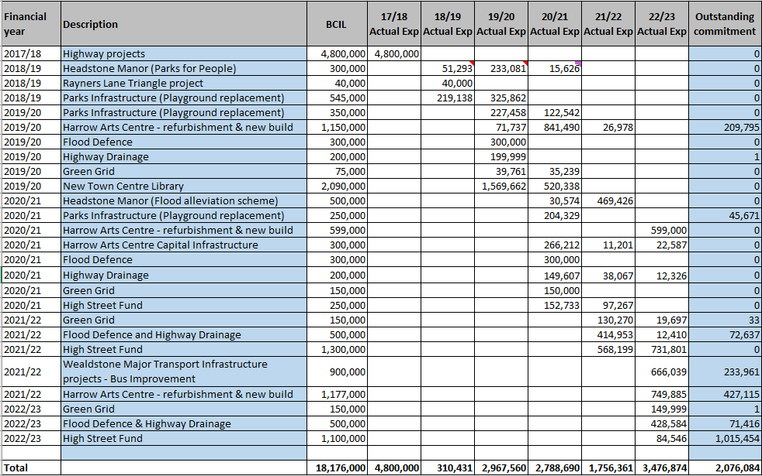

- Table 5 sets out the balance of CIL funding remaining as at 31st March 2023, plus CIL received in 2023/24 to 26th October 2023, which shows that £9.584m of BCIL and £2.998m of NCIL is available to fund projects from 2023/24 onwards.

Table 5 – CIL Funding available as at 26 October 2023
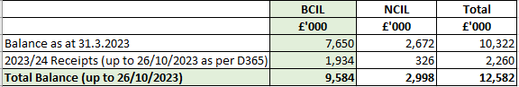

- The projects in the Capital Programme for 2023/24 to 2026/27, to be funded from BCIL, are £6.186m as set out in Table 6 which shows the total spend over financial years.

Table 6: Schemes funded from BCIL from 2023/24 to 2025/26
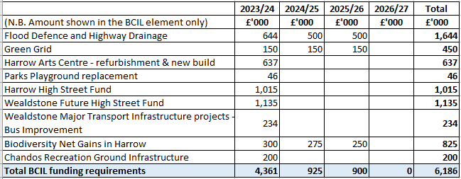

- The total current BCIL available as at 26th October 2023 amounts to £9.584m as set out in Table 5. The total requirement for BCIL funding to cover the total commitment of the existing capital programme is £6.186m as set out in Table 6. This means that there is uncommitted BCIL funding of £3.398m available for further eligible projects at the time of writing this report.

- Given that BCIL averages £2m per annum, it could be anticipated that a further £6m of BCIL would be received in 2024/25 to 2026/27 available to fund new projects in the Capital Programme. This would then lead to a reduction in borrowing costs if schemes currently funded from borrowing could be substituted by BCIL funding instead (subject to confirmation that they are eligible for BCIL funding). As detailed in paragraph 19, considerations should also be given on the allocation of BCIL funding while the updated IDP and Harrow Local Plan are being prepared.

Housing Revenue Account (HRA)

- The proposed HRA Capital Programme will be detailed in a separate report to Cabinet in January 2024. Any implications from the HRA Capital Programme are funded from the Housing Revenue Account and do not impact upon the General Fund Budget. The HRA Capital Programme will be included in the Final Capital Programme report going to Cabinet in February 2024.

Options considered

- A review of the current Capital Programme was undertaken during the budget setting process. The outcomes are set out in paragraph 6 of this report. These also form the basis for preparing the Draft Capital Programme 2024/25 to 2026/27.

Legal Implications

- Under the Financial Regulations paragraph B2, full council is responsible for agreeing the authority’s policy framework which are proposed by Cabinet, and this includes the capital programme. Under B41 the Director of Finance is responsible for producing an annual capital strategy for Cabinet to recommend to Council.

Financial Implications

- Financial matters are integral to this report. The capital financing costs of all capital investment must be provided for within the revenue budget.

Procurement Implications

- There are no procurement implications arising from this report.

Performance Issues

- The capital programme proposed represents a significant investment by the Council in infrastructure. This will have an impact on a range of performance indicators across the Council’s services.

- Monitoring of the approved programme is ongoing and is essential for good financial management.

- It is proposed that a performance target is set of 90% of the approved budget to be spent in year. Having approved an investment programme it is important that the programme is then substantially delivered in the planned timeframe, in line with member priorities.

Risk Management Implications

- Risks included on corporate or directorate risk register? No

- Separate risk register in place? No

- The relevant risks contained in the register are attached/summarised below. n/a

- The following key risks should be taken onto account when agreeing the recommendations in this report:

Risk Description | Mitigations | RAG Status
Proposals put forward by Directorates are not part of an agreed Corporate Asset Management Plan(s) and therefore it is not possible to confirm that the proposals put forward cover the full estate which could lead to an increase in health and safety risks and additional costs in replacing assets if they deteriorate too much to repair. | Two of the key criteria for including projects in the capital Programme are those projects that are needed to ensure that we continue to invest in our capital assets to ensure the Council meets its requirements for both Life and Limb/Health and Safety requirements and to fulfil the Council’s Statutory and legislative duties.
The costs of the Capital proposals are not affordable. | No new capital has been included in 2026/27 and therefore the capital financing costs of all proposals in the Capital Programme are included in the 3 year period covered by the current MTFS up to 2026/27. .
The risk that the required level of BCIL does not materialise. | As the Capital programme is an annual process and the BCIL funding is now included in the report each year to Cabinet, the availability of BCIL to fund the Capital Programme is kept under review. In normal circumstances, should the level of BCIL not be sufficient then either the schemes can be removed from the programme or funded from an alternative source. If that source is borrowing then the revenue cost of borrowing will need to be included in the revenue budget. However, for 2023/24 there is sufficient BCIL funding to meet existing commitments in the Capital Programme -see paragraphs 24 and 25.

Equalities implications / Public Sector Equality Duty

- One of the aims of the Capital Strategy is to ensure the responsible allocation of funding in line with the Council’s priorities and legislative requirements such as equalities legislation. The officer’s views are that no protected group is adversely affected by the proposals.

- Decision makers should have due regard to the public sector equality duty in making their decisions. Consideration of the duties should precede the decision. It is important that Cabinet has regard to the statutory grounds in the light of all available material such as material in the press and letters from residents. The statutory grounds of the public sector equality duty are found at section 149 of the Equality Act 2010 and are as follows:

A public authority must, in the exercise of its functions, have due regard to the need to:

  - eliminate discrimination, harassment, victimisation and any other conduct that is prohibited by or under this Act;

  - advance equality of opportunity between persons who share a relevant protected characteristic and persons who do not share it;

  - foster good relations between persons who share a relevant protected characteristic and persons who do not share it.
The relevant protected characteristics are:

- Age
- Disability
- Gender reassignment
- Pregnancy and maternity
- Race,
- Religion or belief
- Sex
- Sexual orientation
- Marriage and Civil partnership

- Council Priorities
The Council’s Draft Capital Programme for 2024/25 to 2026/27 have been prepared in line with the Council’s priorities set out below:

- A council that puts residents first
- A borough that is clean and safe
- A place where those in need are supported

Section 3 - Statutory Officer Clearance
Statutory Officer: Sharon Daniels
Signed by the Chief Financial Officer
Date: 21/11/2023

Statutory Officer: Paresh Mehta
Signed on behalf of the Monitoring Officer
Date: 22/11/2023

Chief Officer: Alex Dewsnap
Signed by the Managing Director
Date: 20/11/2023

Head of Procurement: Nimesh Mehta
Signed by the Head of Procurement
Date: 15/11/2023

Head of Internal Audit: Neale Burns
Signed on behalf of the Head of Internal Audit
Date: 15/11/2023
Has the Portfolio Holder(s) been consulted? Yes ☒

Mandatory Checks

Ward Councillors notified: NO, as it impacts on all Wards

EqIA carried out: NO as these capital proposals are in the main rolling programme items which will improve the Council’s infrastructure and assets.

EqIA cleared by: N/A

Section 4 - Contact Details and Background Papers

Contact: Jessie Man, Interim Head of Strategic and Technical Finance (Deputy S151)
Email: jessie,man@harrow.gov.uk

Background Papers: none

Call-in waived by the Chair of Overview and Scrutiny Committee: No

